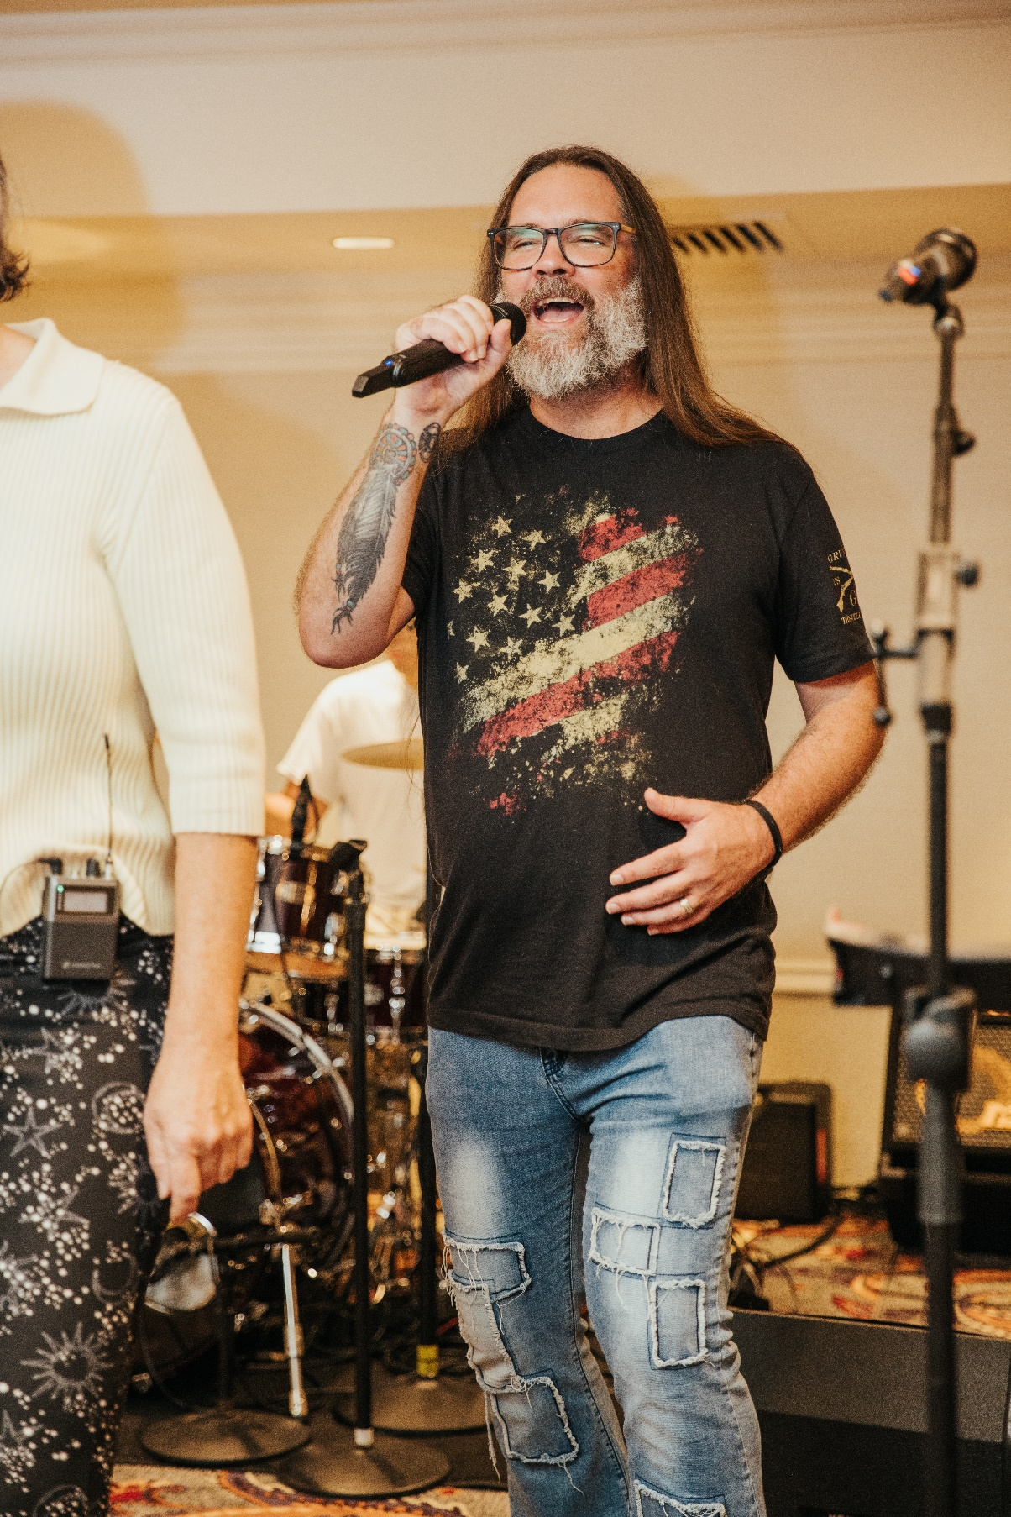

**Spectera Introduced to the Americas at Spectrum Management Conference**

**Ushering in a New Era for Wireless Microphone Technology**

***Washington D.C., January 21, 2025–* Sennheiser highlighted its revolutionary new Spectera system and made a presentation on the future use of the 1.4 GHz band for wireless microphone operations during the Americas Spectrum Management Conference that took place in Washington DC on October 1st & 2nd. Conference attendees traveled from a wide variety of North, Central, and South American countries. Spectrum regulators, analysts, and leading engineers gathered to hear the latest wireless trends and future outlook, as well as witness cutting-edge radio frequency (RF) technology. Spectera has been highly anticipated in the pro audio and spectrum circles due to its ability to densely pack many audio channels within a six to ten megahertz (MHz) radio frequency band, as well as provide greater protection to other users operating equipment in the same or adjacent frequency bands.**

“Spectera fulfills the goals of the Federal Communications Commission (FCC), and other regulatory authorities around the globe, because it makes more robust use of available spectrum,” notes Joe Ciaudelli, Sennheiser’s Director of Spectrum & Innovation. “This is achieved by flexible spectral resource allocation, higher transmission reliability with low power spectral density, and bidirectional communication between the Spectera base station and the portable transceivers.” Spectera is based on a broad bandwidth technology known as Wireless Multichannel Audio Systems (WMAS). This required a rule change by the FCC in the bandwidth permitted for wireless microphones. Over the course of nearly six years, Sennheiser provided studies and made WMAS demonstrations to the FCC. Dozens of audio industry leaders also wrote letters to the FCC in support. After thorough consideration and scrutiny, the five Commissioners of the FCC voted unanimously to approve the rule change last February. Their ruling was recently published in the U.S. Federal Register on October 18th. Rulings become effective 30 days after publication. Thus, it officially becomes the law of the land throughout the United States and its territories on November 17th.

American Idol *star Bo Bice performing at the Spectrum Management Conference. Photo courtesy of CPI.*

During the conference’s evening reception, the Spectera system was used for in-ear monitoring (IEM) for performances featuring the Sonic Crusaders and American Idol star Bo Bice. “We have eleven people on stage so I always need reliable wireless,” explained Jason Banta, audio engineer for the Sonic Crusaders. He adds, “With IEMs and wireless microphones, I have a lot in the air. In downtown Dubai, where I first used Spectera during an outdoor concert, and now in Washington D.C., Spectera was rock solid and sounded great.”

**1.4 GHz band**

Spectera will be first available in the traditional UHF-TV frequency band, then alternative bands thereafter. Joe Ciaudelli gave a presentation during the conference summarizing the collaboration between the pro audio industry and the Aerospace and Flight Test Radio Coordinating Council, Inc. (AFTRCC) for compatible sharing of the 1.435 – 1.525 Gigahertz (GHz) frequency band. This band will become increasingly important to licensed mic operators staging major events (e.g. greater than 100 audio channels). The primary RF service in this band is Aeronautical Mobile Telemetry (AMT), i.e., flight testing. This life critical service must be protected. This is achieved through coordination by AFTRCC. In the future, audio professionals licensed under FCC Part 74 rules will be able to apply to AFTRCC to use this frequency band operating equipment that will have location, date, and time awareness.



*Singer Rhiannon Elliott performing at the Spectrum Management Conference. Photo courtesy of CPI.*

Upon receiving an event application, AFTRCC will check with both Federal Agencies (e.g., Air Force) and private industry (e.g., Boeing) to ensure no flight testing is scheduled to take place at the requested event location, date(s), and time(s). If all clear of flight testing, ATFRCC will issue an electronic key that can be loaded into the mic system that will unlock it so that the components can operate at the approved site and time.

“Operation of Spectera in this frequency band will allow the sophistication of events such as the Olympics, Super Bowl, Oscars, and Grammy Awards to continue to flourish,” stated Ciaudelli. “Sennheiser continues to innovate and meet the challenges faced by audio professionals. Spectera took more than a decade of commitment and ingenuity by our development engineers. It will completely change how large events are staged or broadcasted.”

[ends]

**About Sennheiser Group**

Building the future of audio and creating unique sound experiences for our customers - this is the aspiration that unites the employees of the Sennheiser Group worldwide. The independent family-owned company Sennheiser was founded in 1945. Today, it is managed in the third generation by Dr. Andreas Sennheiser and Daniel Sennheiser, and is one of the leading manufacturers in the field of professional audio technology.

[sennheiser.com](https://protect-eu.mimecast.com/s/lUszCgxgJHAZzmKWSo3cGI?domain=sennheiser.com) | [neumann.com](https://protect-eu.mimecast.com/s/hW3dCm2oZUjNQA8YSDwLrJ?domain=neumann.com) | dear-reality.com | [merging.com](https://www.merging.com/)

**Local Press Contact**

Daniella Kohan

Daniella.kohan@sennheiser.com

+1 (860)-598-7420

Kirsten Spruch

[Kirsten.Spruch@sennheiser.com](mailto:Kirsten.Spruch@sennheiser.com)

+1(959)-239-7383